The Series 380 is a Btu Transmitter capable of communicating with higher level languages including MODbus and BACnet on an RS-485 network; however, sometimes a simple local display of total Flow or Energy is desired.

Often the local display of total is installed while the larger system is being implemented, and then left in place as back-up and for local indication.

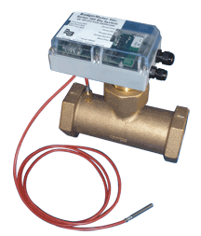

The Model RED is an easy to install, low cost, battery operated totalizing display.

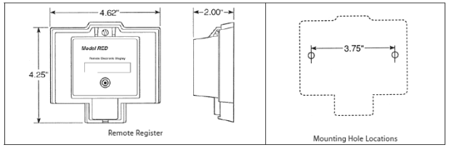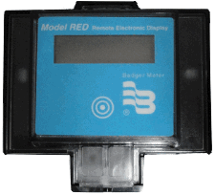

The Model RED is a very simple two wire device that simply increments a counter each time it receives a pulse.

To extend battery life, the display only shows a value for about 20 seconds when the round circle on the front panel is pressed. The same button is used to program the RED.

Programming is very simple, involving only entering a starting number, and setting the decimal point.

It should be noted that since the Model RED is designed to be used with devices like Badger’s RTR, to make it compatible with the Model 380, some special wiring is required which includes the addition of a 1N4000 series or similar diode across the pulse output terminals of the Model 380. (1N4001 thru 1N4007 – All work equally well)

Wiring:

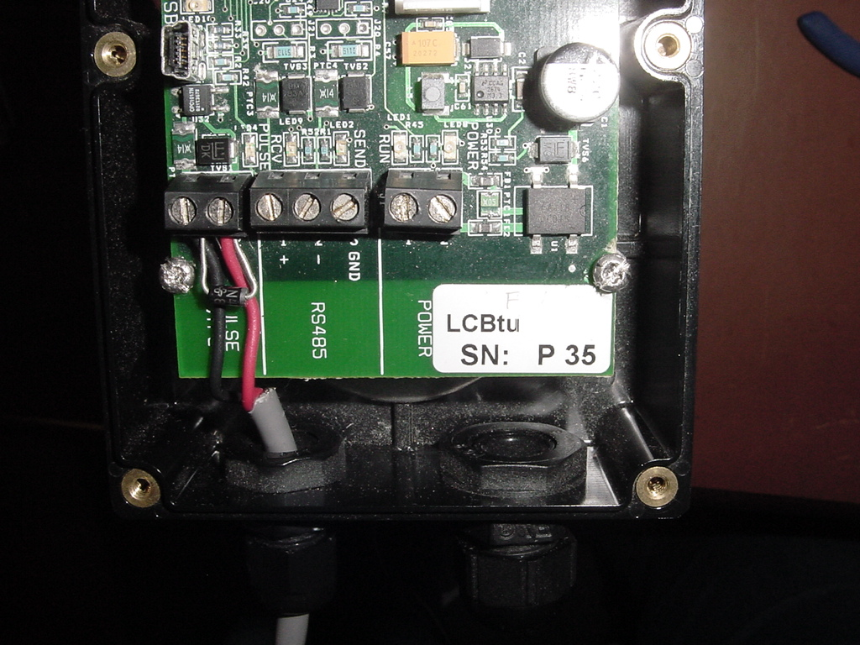

**IN4000 Series**

**or**

**Similar Diode**

**Red Wire to Model RED**

**Black Wire to Model RED**

**Pulse Output**

**1 2**

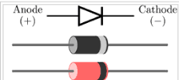

Maximum Cable run is 3000 Ft using Belden 8451 Cable

( Not provided)

Banded End (Cathode) of

1N4000 Series Diode

Programming:

The Model 380 is configured using an A-301 programming kit, using windows based software.

1. 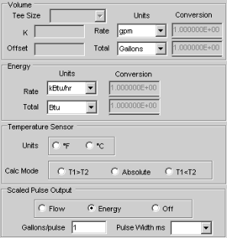Choose if the Pulse Output is to represent Flow or Energy
2. Select units of measure ( Global for MODbus, BACnet, and Pulse out)
3. Set Pulse Width to 50mS ( Required by RED)
4. The selection of Units/Pulse requires some planning   
    The Model RED is a Seven (7) digit counter.  
    When choosing the Pulse Resolution and units of measure  
    they must be selected so that counter does not roll-over too quickly,  
    and yet occurs in a reasonable amount of time.  
    If the counter is not to roll over in less than 10 years the  
    average count rate should not exceed 1 count/30 Seconds.

5. The RED has a multiplier enunciator that can be set to   
 x1, x10, x100, or x1000. However, since the Model 380 is fully  
 programmable, to conserve battery life and to stay within the   
 recommended range of the Pulse output of the Model 380, it is   
 recommended that only the “x1” display be used.

6. The Model RED has a Decimal point that can also be positioned as   
 appropriate.

The Model RED has no units of measure displayed, so a customer provided units label would be advised.

(Example: Btu, kBtu, KWh, Ton-Hr, Gallons, Cubic Feet, etc.)   
  
The Model RED is programmed using only the Button on the Front Panel, as shown in the instructions shipped with the counter. This information can also be found on our Web Page.

**Warning:**

Wiring must be completed with Diode in place before the RED is configured or an “E” will appear indicating a “Wiring Error” that must be cleared in before you can continue. (See installation sheet for the Model RED)

It should also be noted that these instruction are for current production Model RED units, older versions are similar and wire exactly the same; however, the decimal point feature is not included, and some of the programming steps are slightly different. Consult the instruction sheet shipped with the Model RED for specific instructions for the version you have.

Programming example:   
Let’s say the Model RED counter is to represent energy total in “kBtu”, and the energy rate is expected to be in the range of a minimum of 1kBtu/Hr to a maximum of 100kBtu/Hr.

If a resolution of 1 kBtu/Pulse was selected, the counter would increment at a maximum rate of   
1 count/36 seconds which would not roll the counter before 11.4 years, which would be good.

However, at the low end, the counter would only increment once every 3600 seconds (1 count/ hour).

If this is an acceptable rate the default “x1enunciator” would be selected and a “kBtu” label made.

However, if the system was not going to be operating at the peak rate, except for short periods, and a higher pulse rate is desired, a selection of 0.1kBtu/Pulse might be a better choice. This will still be only  
1 count/3.6 Sec at the maximum rate which is still within the acceptable range of both the Model RED and the Model 380.

In this case, on the Model RED the default “x1” enunciator would still be used; but, the decimal point would be set to 0000000.0 to match the counts coming from the Model 380, and the label provided by the installer would still read “kBtu”

Each time the 380 sent a pulse representing 0.1kBtu, the RED would increment the least significant digit by 1.

So if a value of 000123.1 kBtu was displayed on the Model RED prior to the receiving the pulse signal from the Model 380, the display would advance to a value of 000123.2 kBtu.